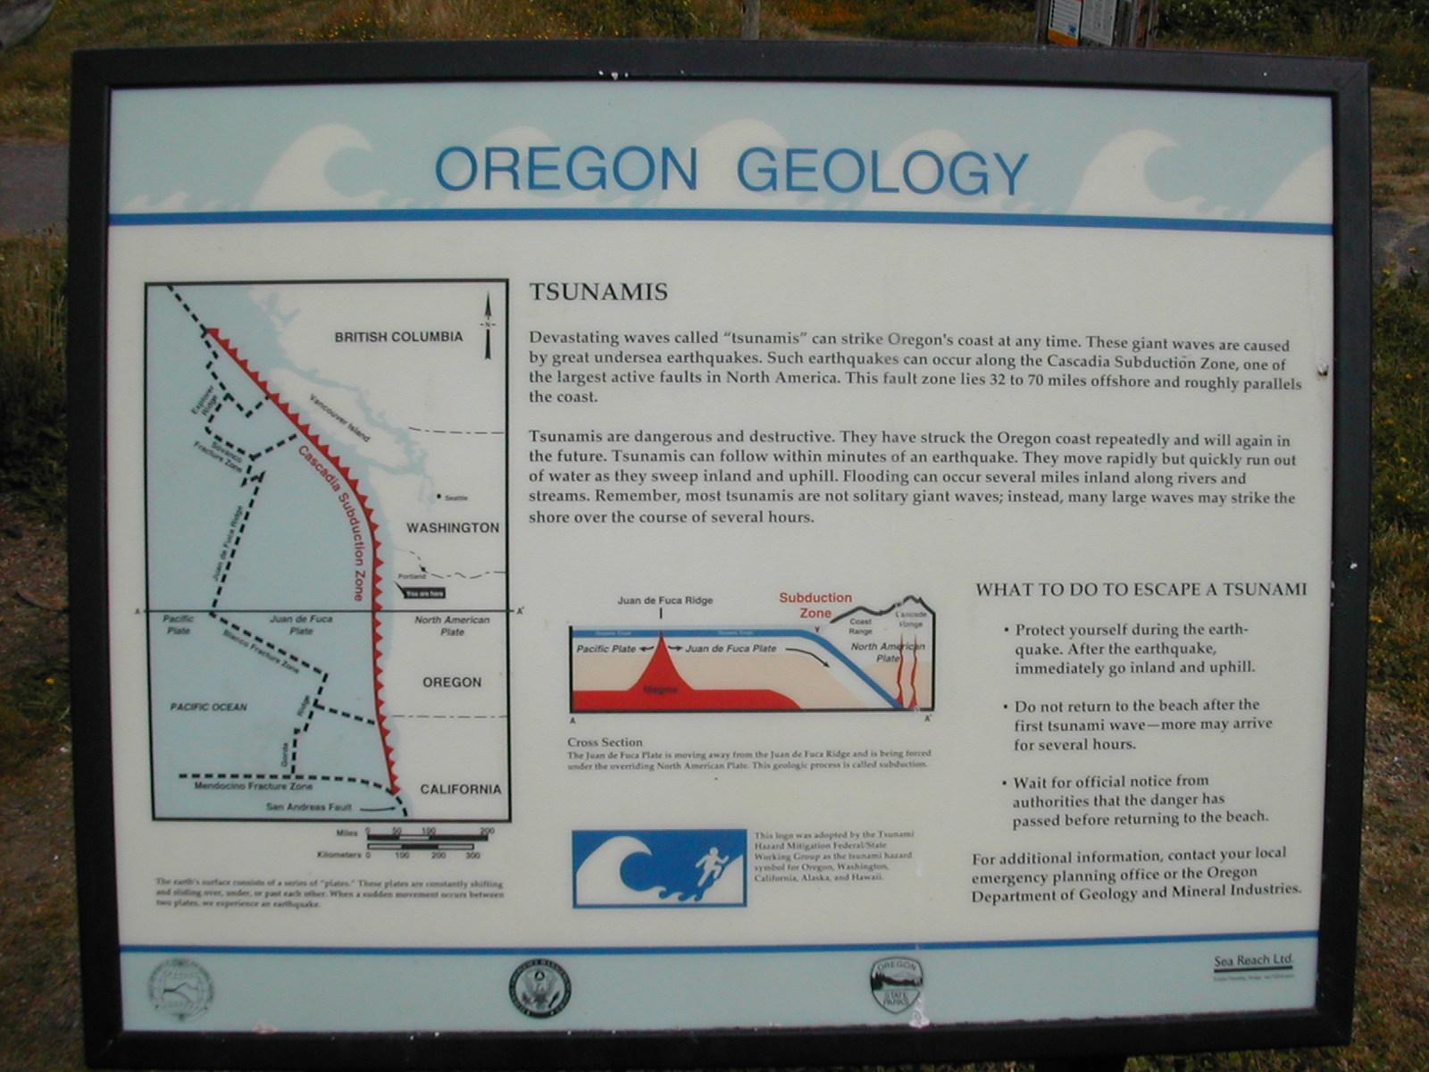
This is an online field course studying the geology of the Central Oregon Coast. Explore the evidence of tectonic earthquakes, the 1700 tsunami, coastal erosion and mitigation.
There will be no face-to-face or D2L instruction. All instructions for this class are contained in this syllabus. Papers are due by 5 PM, Friday, March 19, 2021, delivered by email to scarlson@pdx.edu.
Review the following web resources and cite references to them in your paper.
Sept 1993 issue of Oregon Geology [124 pgs]
Excerpt from March 1998 issue of Geology [8 pgs]
Local Tsunamis in the Pacific Northwest [11 pgs]
Research Sheds New Light on Tensions Along Cascadia Fault [6 pgs]

View the following
Video: Great Earthquakes of the Pacific Northwest [1:04 hrs]
Video: Unprepared: An Oregon Field Guide Special [56 min]
Please Review and comment on this rough draft of the virtual trip
https://www.dropbox.com/sh/mlqfhwoqt8bhg3b/AAAKmwzF4DndN4ajovYjDJija?dl=0

Assignment: Using the handouts and online resources listed above, write a paper of 1000-1500 words to answer the following questions.
- What would be a possible sequence of events in a major earthquake along the Oregon-Washington coastline?
- What mitigation efforts should be taken to protect life and property in the event of major earthquakes or tsunami near the Oregon coast?
- How might the geology of the Central Oregon Coast relate to your chosen college major, your life in the present or the future.
Use standard formatting: 1-½” margins, double-spaced. Use and cite at least three sources including course handouts, Oregon Geology Volume 55, #5, 9/93, online encyclopedias and USGS webpages.

